CONFIGURING RIP

Q1. Set up a network topology with three routers in Cisco Packet Tracer, connect them using serial or Ethernet links, and assign IP addresses to all interfaces.
Ans. Here I have configured Three Router’s
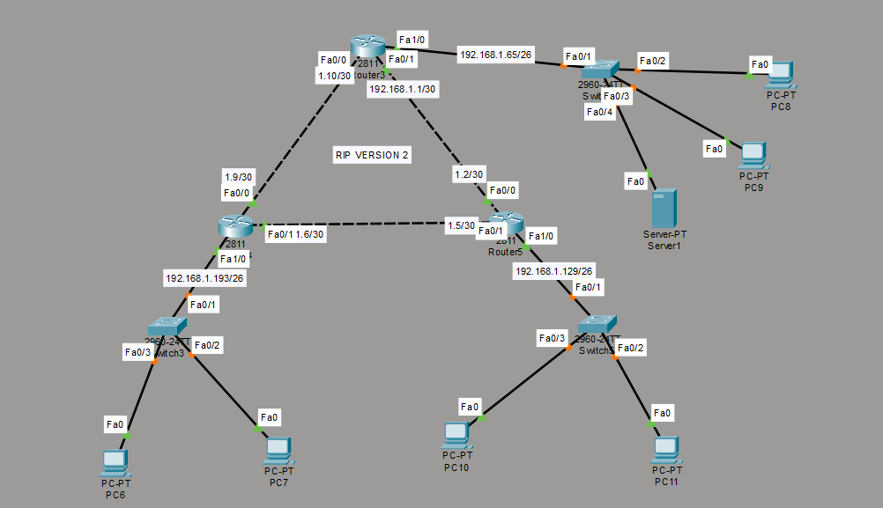
Q2. Enable RIP version 2 on all three routers in your topology, advertise all directly connected networks, and verify that each router learns routes to all subnets using the 'show ip route' command.
Ans. RIP Version 2 is configured on all three routers. With the interfaces active and networks correctly advertised, each router automatically learns the remote subnets. In the routing table, R indicates a RIP-learned route, and [120/1] indicates administrative distance 120 and hop count 1.
Q3. Change the hop count metric for one of the networks by adding an extra router between two existing routers, then observe and record how the hop count value changes in the routing tables.
Ans. I have added a new router and the hop count changes to 2
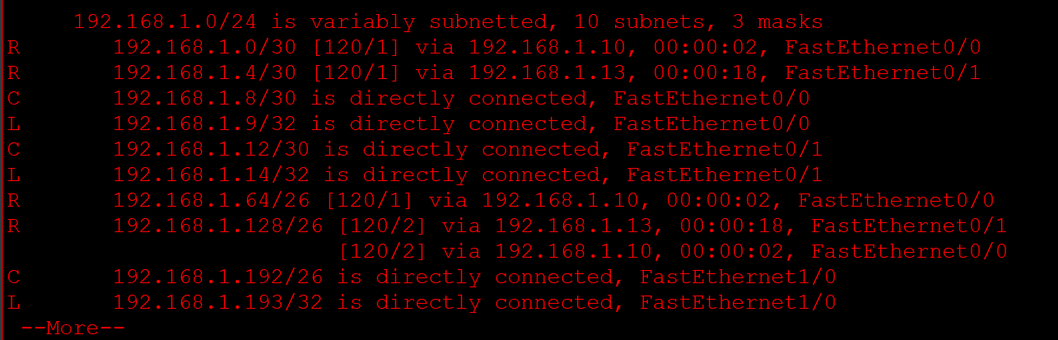
Q4. Use the simulation mode in Cisco Packet Tracer to capture and analyse RIP update packets as they are exchanged between routers. Hint: Filter for RIP packets in the simulation panel and note the source, destination, and advertised routes in each update.

Ans. Result: In Cisco Packet Tracer Simulation Mode, a RIP Version 2 update packet was captured from Router4 to Router3. The packet originated from IP address 192.168.1.9 and was sent to multicast address 224.0.0.9 using UDP port 520. This confirms that the routers are exchanging RIP Version 2 updates.

